BASAVARAJESWARI GROUP OF INSTITUTIONS

BALLARI INSTITUTE OF TECHNOLOGY & MANAGEMENT
NBA and NACC Accredited Institution*
(Recognized by Govt. of Karnataka, approved by AICTE, New Delhi & Affiliated to Visvesvaraya
Technological University, Belagavi) "JnanaGangotri" Campus, No.873/2,
Ballari-Hosapete Road, Allipur, Ballari-583 104 (Karnataka) (India)
Ph:08392 – 237100 / 237190, Fax: 08392 – 237197

BALLARI INSTITUTE OF TECHNOLOGY & MANAGEMENT
NBA and NACC Accredited Institution*
(Recognized by Govt. of Karnataka, approved by AICTE, New Delhi & Affiliated to Visvesvaraya
Technological University, Belagavi) "JnanaGangotri" Campus, No.873/2,
Ballari-Hospet Road, Allipur, Ballari-583 104 (Karnataka) (India)
Ph:08392 – 237100 / 237190, Fax: 08392 – 237197

BALLARI INSTITUTE OF TECHNOLOGY & MANAGEMENT
NBA and NACC Accredited Institution*
(Recognized by Govt. of Karnataka, approved by AICTE, New Delhi & Affiliated to Visvesvaraya
Technological University, Belagavi) "JnanaGangotri" Campus, No.873/2,
Ballari-Hospet Road, Allipur, Ballari-583 104 (Karnataka) (India)
Ph:08392 – 237100 / 237190, Fax: 08392 – 237197

BALLARI INSTITUTE OF TECHNOLOGY & MANAGEMENT
NBA and NACC Accredited Institution*
(Recognized by Govt. of Karnataka, approved by AICTE, New Delhi & Affiliated to Visvesvaraya
Technological University, Belagavi) "JnanaGangotri" Campus, No.873/2,
Ballari-Hospet Road, Allipur, Ballari-583 104 (Karnataka) (India)
Ph:08392 – 237100 / 237190, Fax: 08392 – 237197



DEPARTMENT OF
ARTIFICIAL INTELLIGENCE AND MACHINE LEARNING
A
Project Report
On
“MEDICAL RECORD SEARCH SYSTEM”
Submitted in partial fulfillment of the requirements for the course of
Python Internship

Submitted By

TUSHAR CHOWDHARI 3BR22AI172
JAYAVARDHANA A 3BR23AI060
K PRAVEEN 3BR23AI065
KRISHNA N 3BR23AI079
N VARUN 3BR23AI103

Under the Guidance of

Ms. Neha

Technical Trainer

Visvesvaraya Technological University
Belagavi, Karnataka
2025-2026

BASAVARAJESWARI GROUP OF INSTITUTIONS

BALLARI INSTITUTE OF TECHNOLOGY & MANAGEMENT
NBA and NACC Accredited Institution*
(Recognized by Govt. of Karnataka, approved by AICTE, New Delhi & Affiliated to Visvesvaraya
Technological University, Belagavi) "JnanaGangotri" Campus, No.873/2,
Ballari-Hosapete Road, Allipur, Ballari-583 104 (Karnataka) (India)
Ph:08392 – 237100 / 237190, Fax: 08392 – 237197



DEPARTMENT
OF
ARTIFICIAL INTELLIGENCE AND MACHINE LEARNING

CERTIFICATE

This is to certify that Seminar entitled “MEDICLA RECORD SEARCH SYSTEM” has been successfully completed by Team Members TUSHAR CHOWDHARI, JAYAVARDHANA A, K PRAVEEN, KRISHNA N, N VARUN bearing USNs 3BR22AI172, 3BR23AI060, 3BR23AI065, 3BR23AI079, 3BR23AI103Bonafide students of Ballari Institute of Technology and Management, Ballari, for the partial fulfillment of the requirements for the Python Internship in Artificial Intelligence and Machine Learning during the academic year 2025-2026.
The participant demonstrated enhanced skills in observation, communication, critical thinking, teamwork, and presentation. The visit and seminar also fostered professionalism, confidence, and effective time management.

Signature of Trainer Signature of Head of the Department
Ms. Neha Dr. B M Vidyavathi
Technical Trainer Department of AIML,
BITM, Ballari

ABSTRACT

The management of medical records plays a vital role in ensuring efficient healthcare delivery and patient monitoring. This project presents a simple Medical Record Management System that uses a structured approach to store and retrieve patient information. Each patient is uniquely identified by a patient ID, and their medical history is maintained systematically. The system records multiple visits per patient, storing details such as date of visit, treatment received, current condition, and previous condition. A binary search algorithm is implemented for quick retrieval of patient records, ensuring fast and efficient search operations even in large datasets. By maintaining a detailed visit history, healthcare providers can track a patient’s progress over time, analyze treatment effectiveness, and make informed clinical decisions. This approach demonstrates how basic data structures and algorithms can be applied in healthcare informatics to manage patient data effectively and enhance medical record-keeping.

ACKNOWLEDGEMENT

The satisfaction that accompanies the successful completion of Mini-project work on “MEDICAL RECORD SEARCH SYSTEM” would be incomplete without the mention of people who made it possible, whose noble gesture, affection, guidance, encouragement, and support crowned our efforts with success. It is our privilege to express our gratitude and respect to all those who inspired us in the completion of this project work.
We are extremely grateful to our respective guide Ms. Neha, for her noble gesture, support, coordination and valuable suggestions given to us in completing the project work. We also thank Dr. B M Vidyavathi, H.O.D. Department of AIML, for her coordination and valuable suggestions given to us in completing the project. We also thank the Principal, Management, and non-teaching staff for their coordination and valuable suggestions given to us in completing the project work.

NAME USN
Tushar Chowdhari 3BR22AI172
Jayavardhana A 3BR23AI060
K Praveen 3BR23AI054
Krishna N 3BR20AI079
N Varun 3BR23AI103

Table of Contents
 | Abstract | I
 | Acknowledgement | II
 | Table of Contents | III
1 | Introduction | 1
2 | Problem Statement | 2
3 | Objectives | 3
4 | Design and Implementation | 4-10
5 | Results | 11
6 | Conclusion | 12
7 | References | 13

CHAPTER 1

INTRODUCTION

In modern healthcare, maintaining accurate and comprehensive medical records is essential for effective patient care. A medical record serves as a central repository of a patient’s health information, including their personal details, diagnoses, treatments, and progress over time. Traditional record-keeping methods, often paper-based, are prone to errors, misplacement, and inefficiency, making it difficult for healthcare providers to track a patient’s history accurately.

This project introduces a Medical Record Management System that digitally stores and organizes patient information. Each patient is assigned a unique patient ID, and their records include not only basic details but also a detailed visit history. For every visit, the system records the date, treatment received, current condition, and previous condition, enabling healthcare providers to analyze a patient’s medical journey comprehensively.

The system employs a binary search algorithm to retrieve patient records quickly, ensuring efficient access even as the dataset grows. By capturing both present and past medical conditions, this approach allows doctors to monitor patient progress, evaluate treatment effectiveness, and support better decision-making.

Overall, this project demonstrates the application of object-oriented programming and searching algorithms in the field of healthcare informatics, highlighting how digital solutions can improve record management, enhance efficiency, and ensure continuity of care.

CHAPTER 2

PROBLEM SATEMENT

To design and develop a Medical Record Management System that stores and manages patient information along with detailed visit histories. Each patient record should include a unique patient ID, personal details, and multiple visits containing the date, treatment received, current condition, and previous condition. The system should support efficient searching of specific medical records (e.g., by patient ID) from a sorted collection using the Binary Search algorithm, which applies the Decrease and Conquer strategy. The solution must ensure quick access, accuracy, and scalability as the number of patients and their visit histories increase, thereby improving healthcare record-keeping and patient monitoring.

CHAPTER 3

OBJECTIVES

- To enable fast and accurate searching of patient records in a medical database.
- To implement and demonstrate the effectiveness of Binary Search.
- To evaluate the time complexity and efficiency of the solution.
- To simulate a real-world hospital record-searching system.

CHAPTER 4

DESIGN & IMPLEMENTATION

Design
1. System Design
The system is designed using an object-oriented approach to represent patients and their visit histories efficiently. The main components are:
- Medical Record Class: Represents a patient, storing the patient ID, name, and a list of all visits.
- Visit Class: Represents each visit of a patient, storing details such as date of visit, treatment received, current condition, and previous condition.
- Data Storage: Patient records are stored in a list that is sorted by patient ID to enable fast searching.
The system design ensures modularity, where each patient’s record is self-contained and can store multiple visits independently.

2. Data Structures Used
List/Array: To store all patient records in a sorted order.
Class Objects: Each patient is represented as a Medical Record object containing multiple Visit objects.
Strings and Integers: For storing patient names, treatments, and dates, as well as patient IDs.

3. Searching Algorithm
The system uses Binary Search, a Decrease and Conquer strategy, to quickly locate a patient record:
- The patient list is sorted by patient ID.
- Binary search repeatedly divides the search interval in half:
- Compare the target ID with the middle element.
- If equal, return the record.
- If smaller, search the left half; if larger, search the right half.
- This ensures O(log n) search time, making the system efficient even with many records.

4. Implementation Steps
- Define Classes: Create Visit and Medical Record classes with appropriate attributes.
- Add Visits: Each patient can have multiple visits, and each visit records the date, treatment, current condition, and previous condition.
- Sort Records: Ensure patient records are sorted by patient ID.
- Binary Search Function: Implement the binary search function to retrieve a patient by ID efficiently.

- Display Information: Once a record is found, display:
- Patient ID and Name
- Total visits
- Current condition
- Detailed visit history with date, treatment, condition, and previous condition.
- Scalability: The system can handle multiple patients, each with multiple visits, without loss of efficiency.
5. User Interaction
- The system prompts the user to enter a patient ID to search.
- If the patient exists, all details and visit histories are displayed in a readable format.
- The system can be extended to allow adding new patients and visits interactively.

Implementation:

Code:

class Visit:
def __init__(self, date, treatment, condition, previous_condition=None):
self.date = date
self.treatment = treatment
self.condition = condition
self.previous_condition = previous_condition if previous_condition else "N/A"

class MedicalRecord:
def __init__(self, patient_id, name):
self.patient_id = patient_id
self.name = name
self.visits = [] # List of Visit objects

def add_visit(self, date, treatment, condition):
previous_condition = self.visits[-1].condition if self.visits else "N/A"
self.visits.append(Visit(date, treatment, condition, previous_condition))

def current_condition(self):
if self.visits:
return self.visits[-1].condition
return "No visits recorded"

def binary_search(records, target_id):
low = 0
high = len(records) - 1

while low <= high:
mid = (low + high) // 2
if records[mid].patient_id == target_id:
return mid
elif records[mid].patient_id < target_id:
low = mid + 1
else:
high = mid - 1
return -1

def main():
# Create patient records
records = [
MedicalRecord(1001, "Alice"),
MedicalRecord(1005, "Bob"),
MedicalRecord(1010, "Charlie"),
MedicalRecord(1015, "Diana"),
MedicalRecord(1020, "Ethan"),
]

# Alice - 4 visits
records[0].add_visit("2025-01-10", "Paracetamol", "Fever Reduced")
records[0].add_visit("2025-02-15", "Rest + Flu Medicine", "Recovered")
records[0].add_visit("2025-03-12", "Vitamin Supplements", "Healthy")
records[0].add_visit("2025-04-01", "Routine Checkup", "Normal")

# Bob - 3 visits
records[1].add_visit("2025-01-20", "Insulin Dose Adjusted", "Stable")
records[1].add_visit("2025-03-05", "Diet Plan Updated", "Improved")
records[1].add_visit("2025-04-10", "Insulin + Exercise Plan", "Well Controlled")

# Charlie - 5 visits
records[2].add_visit("2025-02-01", "Inhaler", "Breathing Improved")
records[2].add_visit("2025-02-20", "Nebulizer", "Under Observation")
records[2].add_visit("2025-03-10", "Inhaler + Oxygen", "Better")
records[2].add_visit("2025-04-01", "Allergy Test", "Mild Allergy Found")
records[2].add_visit("2025-04-18", "Allergy Medicine", "Stable")

# Diana - 4 visits
records[3].add_visit("2025-01-15", "BP Medicine", "High BP Controlled")
records[3].add_visit("2025-02-25", "Routine Check", "Stable")
records[3].add_visit("2025-03-20", "Changed BP Dosage", "Improved")
records[3].add_visit("2025-04-05", "Exercise + Diet", "Normal BP")

# Ethan - 3 visits
records[4].add_visit("2025-01-30", "Oxygen Support", "Severe Covid Symptoms")
records[4].add_visit("2025-02-15", "Antivirals", "Improving")
records[4].add_visit("2025-03-10", "Lung Recovery Therapy", "Recovered")

search_id = int(input("Enter Patient ID to search: "))
index = binary_search(records, search_id)

if index != -1:
record = records[index]
print("\nPatient Found:")
print("ID:", record.patient_id)
print("Name:", record.name)
print("Total Visits:", len(record.visits))
print("Current Condition:", record.current_condition())
print("\nVisit History:")

for i, visit in enumerate(record.visits, 1):
print(f"\nVisit {i}:")
print(f"Date: {visit.date}")
print(f"Treatment: {visit.treatment}")
print(f"Condition: {visit.condition}")
print(f"Previous Condition: {visit.previous_condition}")
else:
print("Patient record not found.")

if __name__ == "__main__":
main()

CHAPTER 5

RESULTS

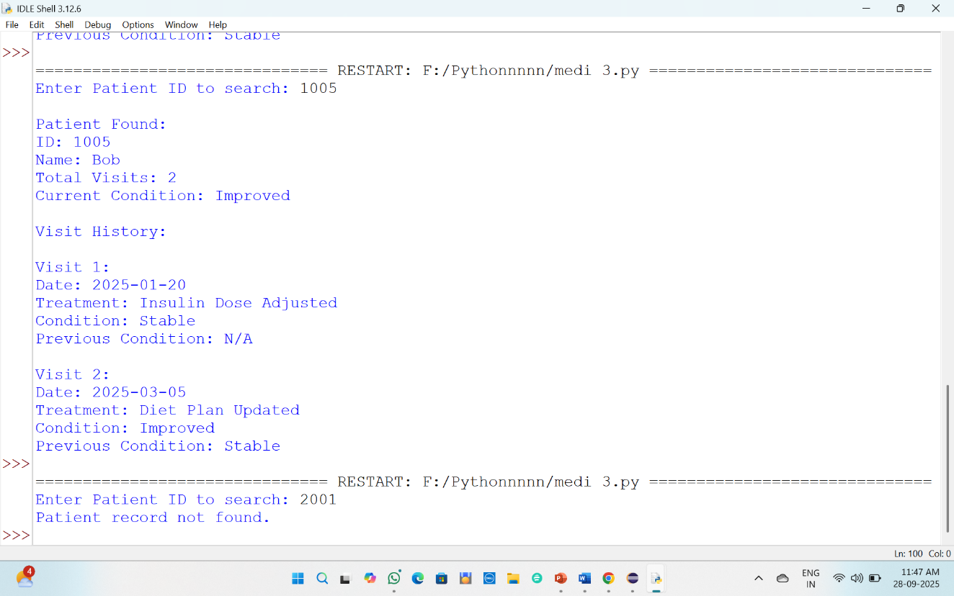

CHAPTER 6
CONCLUSION

The Medical Record Management System efficiently stores and retrieves patient information along with detailed visit histories. Using Binary Search, it ensures quick and accurate access to records, even as the dataset grows. The system tracks treatments, current and previous conditions, helping healthcare providers monitor patient progress and make informed decisions. Its modular design allows for scalability and future enhancements, making it a practical and effective solution for managing medical records.

CHAPTER 7
REFERENCES

- Cormen, T. H., Leiserson, C. E., Rivest, R. L., & Stein, C. (2009). Introduction to Algorithms (3rd ed.). MIT Press.
- Sedgewick, R., & Wayne, K. (2011). Algorithms (4th ed.). Addison-Wesley.
- GeeksforGeeks. (n.d.). Binary Search
- W3Schools. (n.d.).
- IBM Healthcare IT Whitepapers. (n.d.). Retrieved from https://www.ibm.com.
- Chat GPT.

